DSA0409- Fundamentals of Data Science
LAB EXPERIMENTS
Name: K.Tejaswi
Reg.no: 192525407

1. Student Subject Averages using NumPy
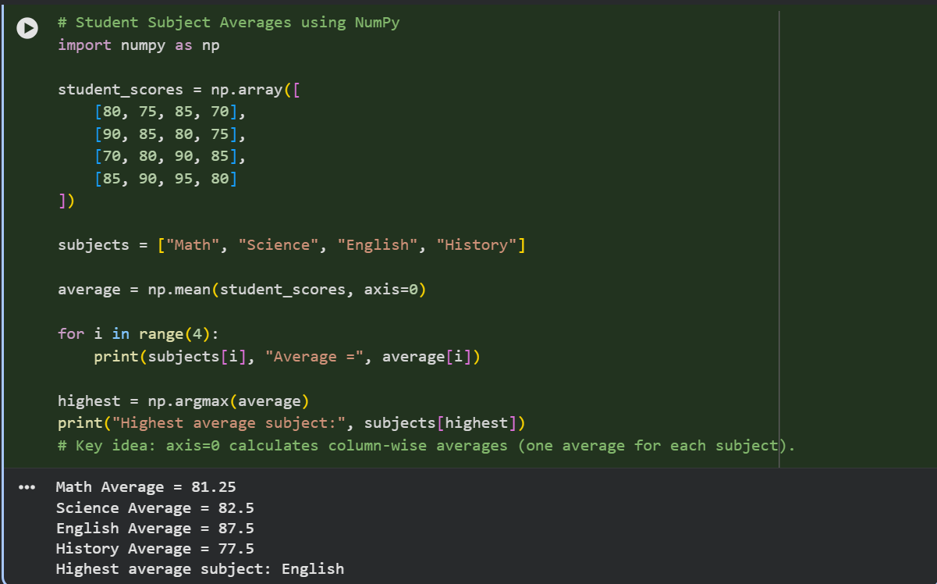

2. Average Product Price using NumPy
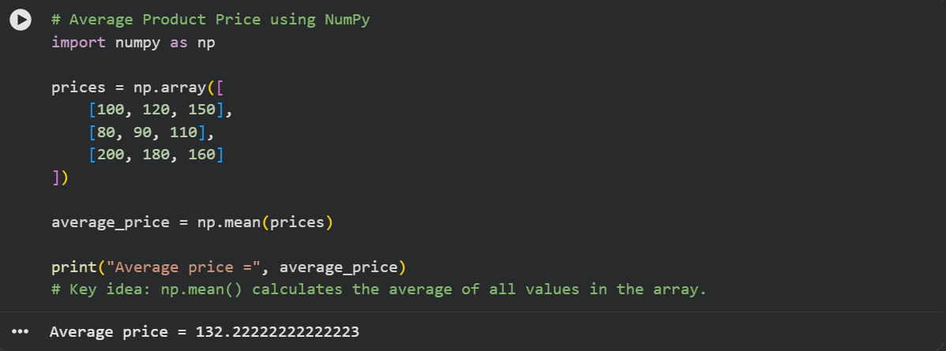

3. Average Sale Price of Houses with More Than 4 Bedrooms
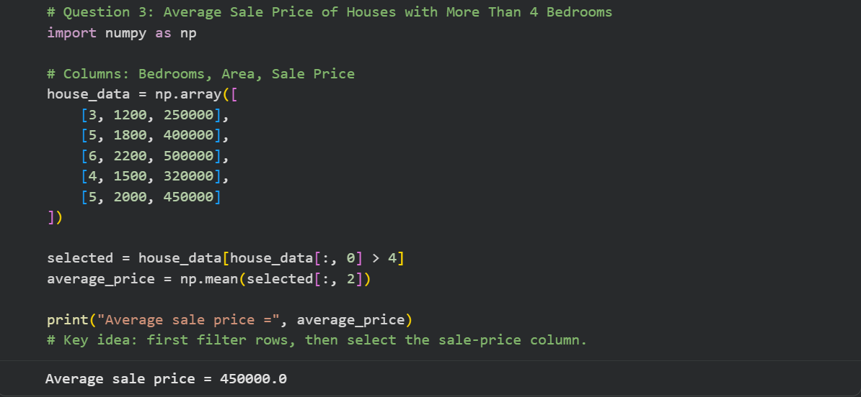

4. Total Yearly Sales and Percentage Increase
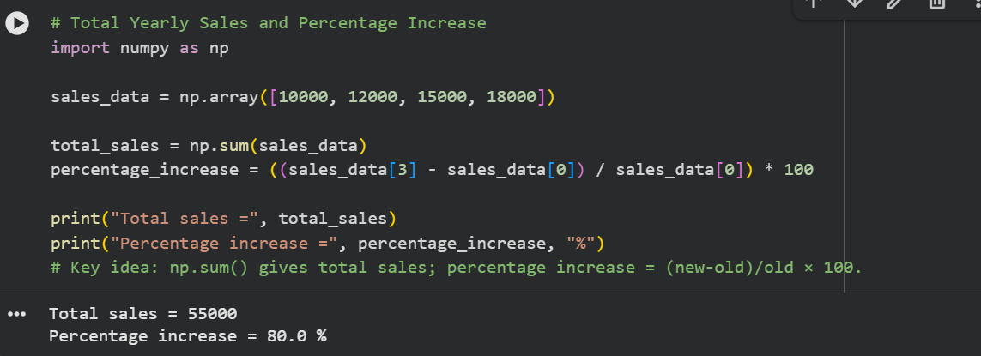

5. Average Fuel Efficiency and Percentage Improvement
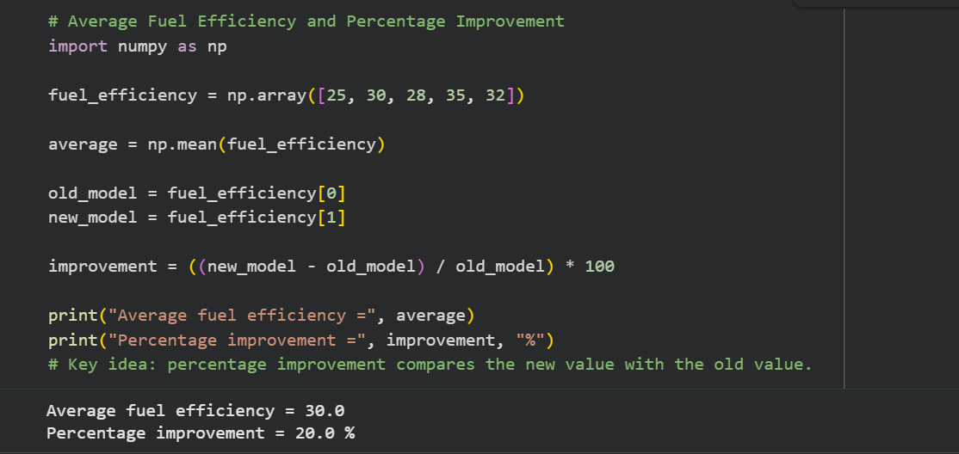

6. Total Grocery Cost with Discount and Tax
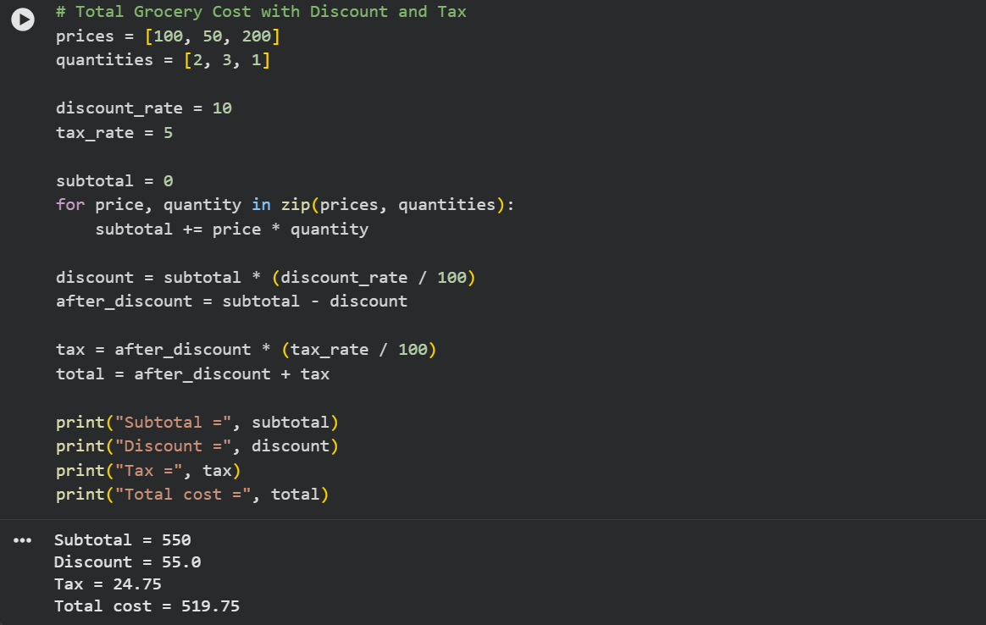

7. Pandas Order Analysis
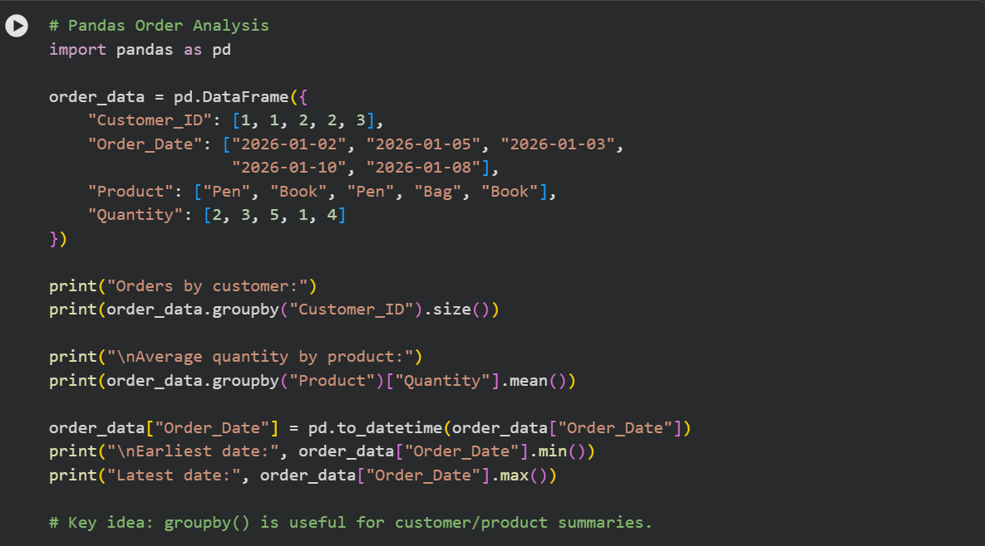
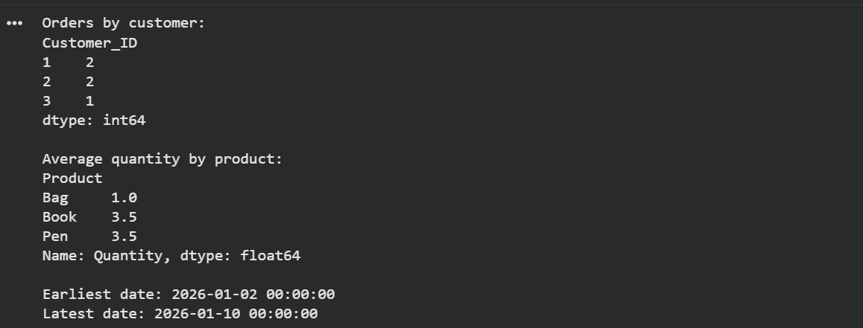

8. Top 5 Products Sold
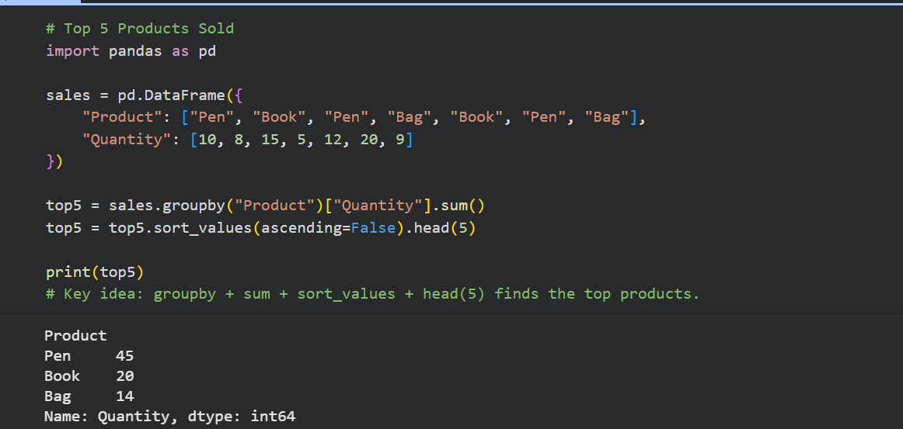

9. Property Data Analysis using Pandas
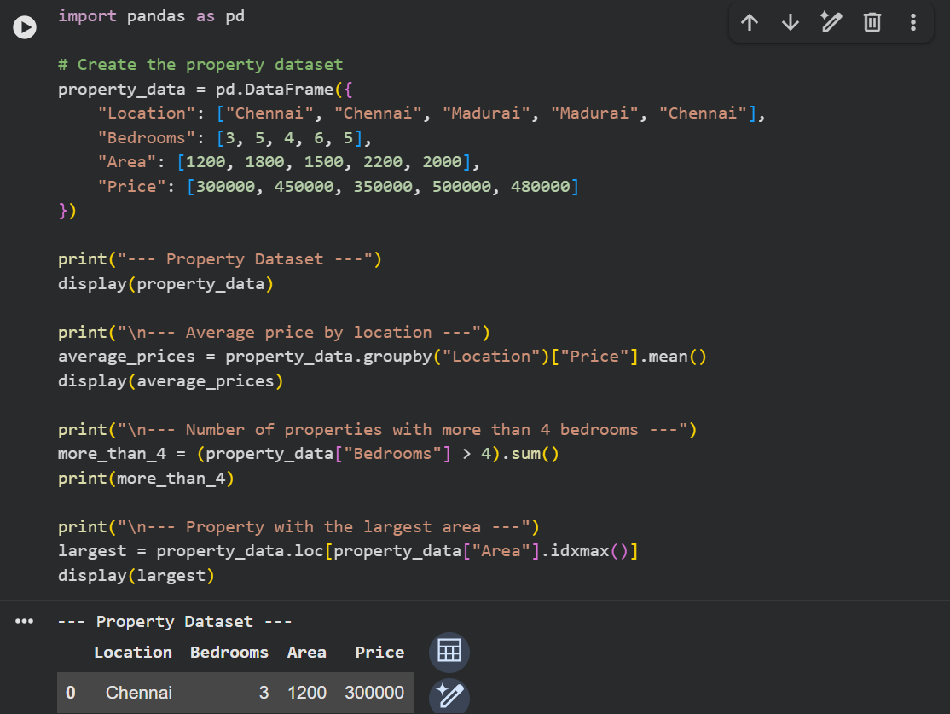
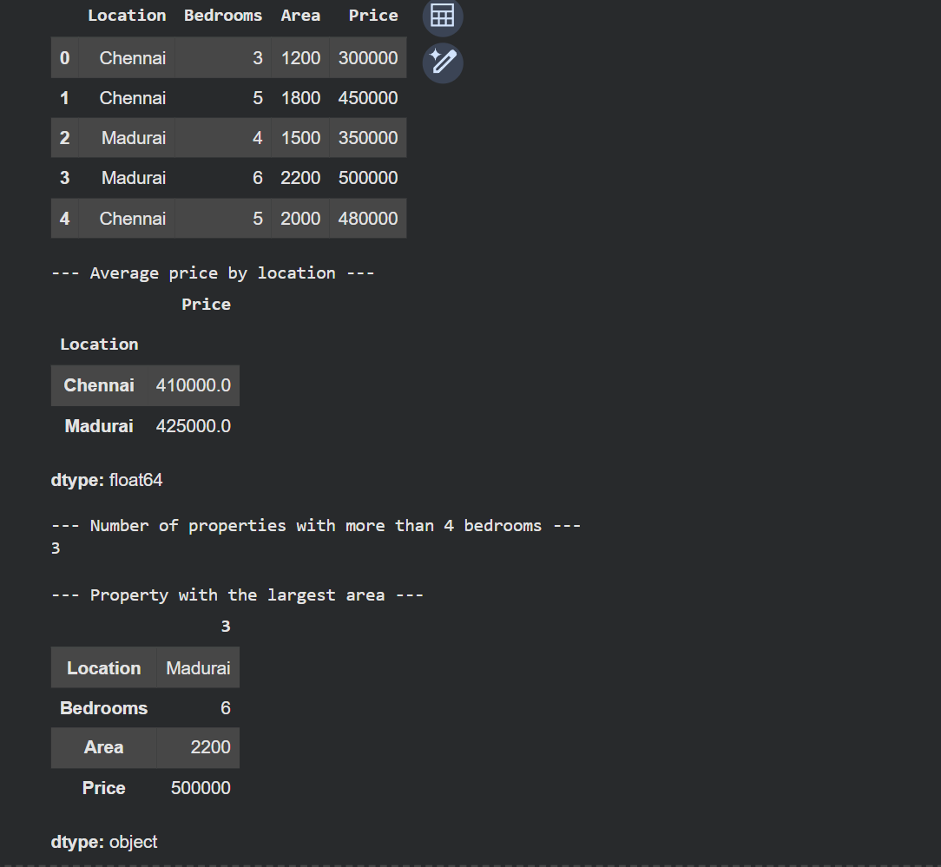

10. Monthly Sales – Line Plot and Bar Plot
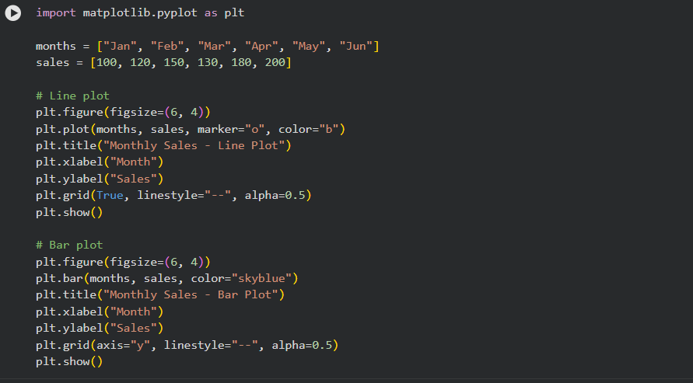

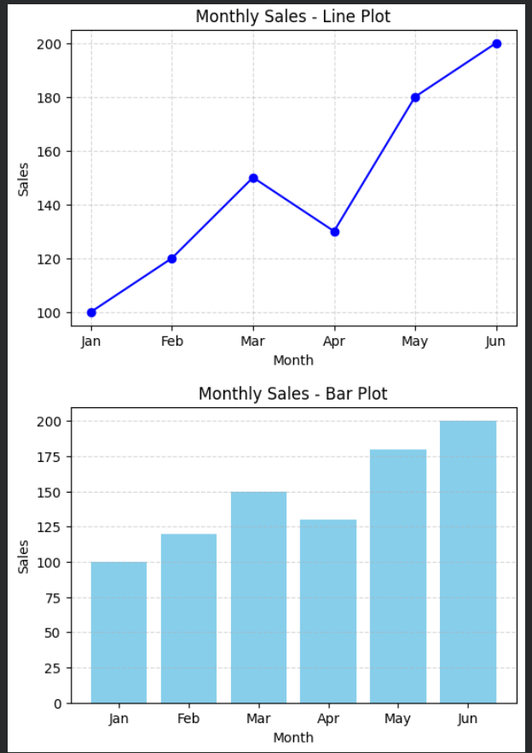

11. Sales over Time – Line, Scatter and Bar Plots
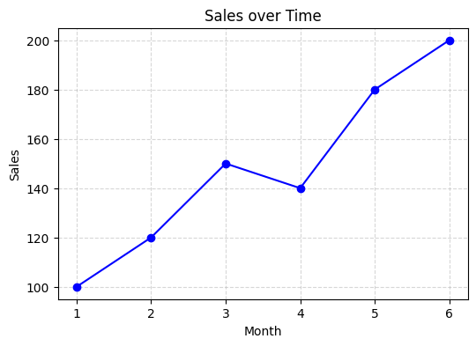
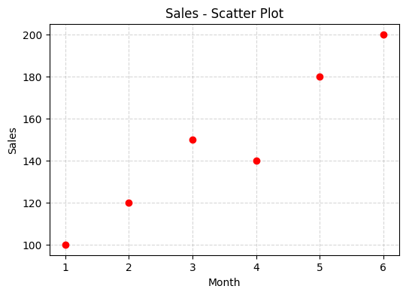
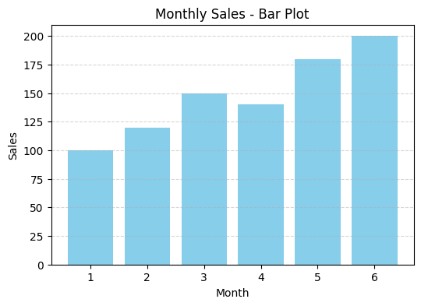

12. Monthly Temperature and Rainfall Plots
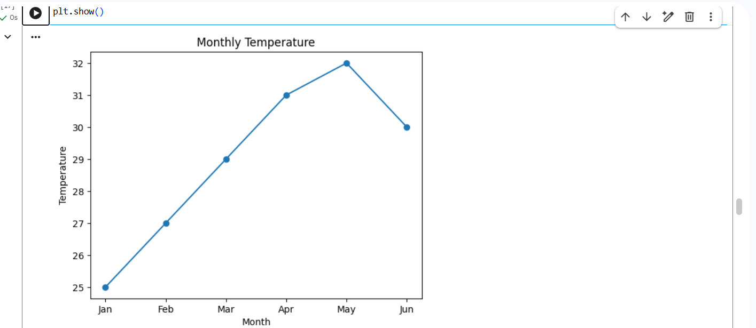
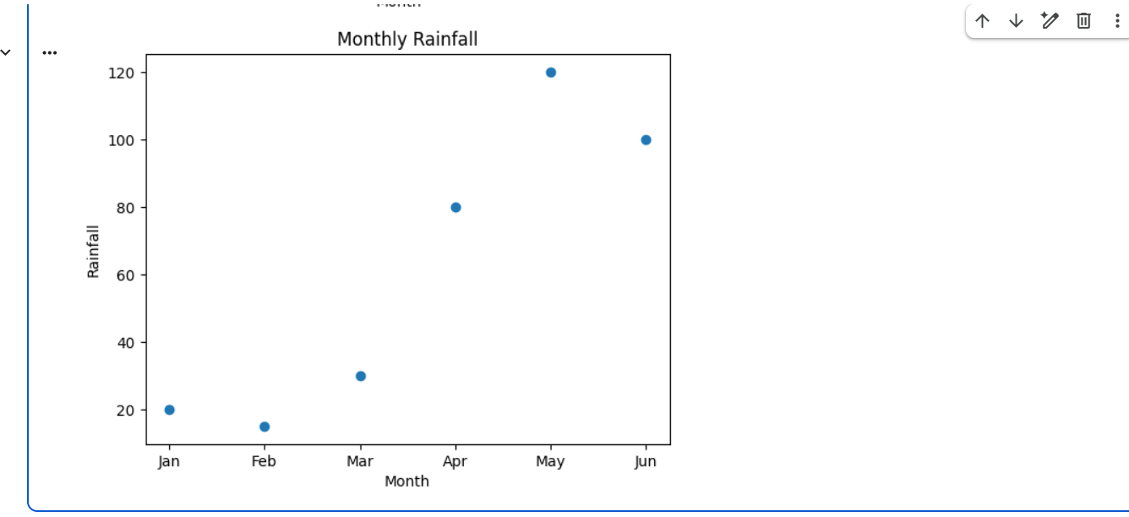

Question 13: Word Frequency from a Text File
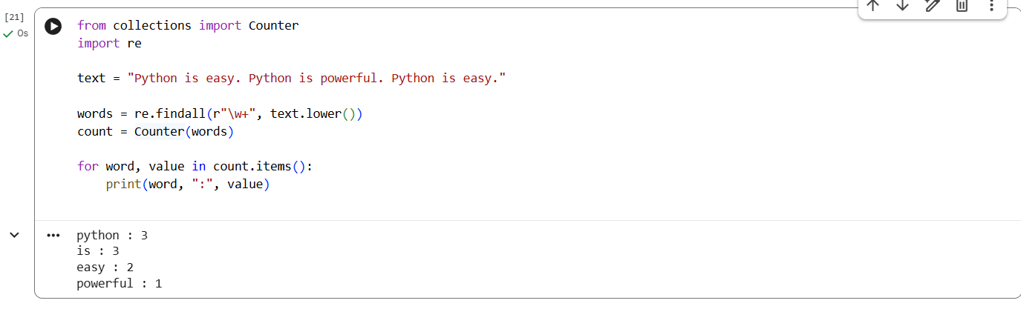
Question 14: Frequency Distribution of Customer Ages
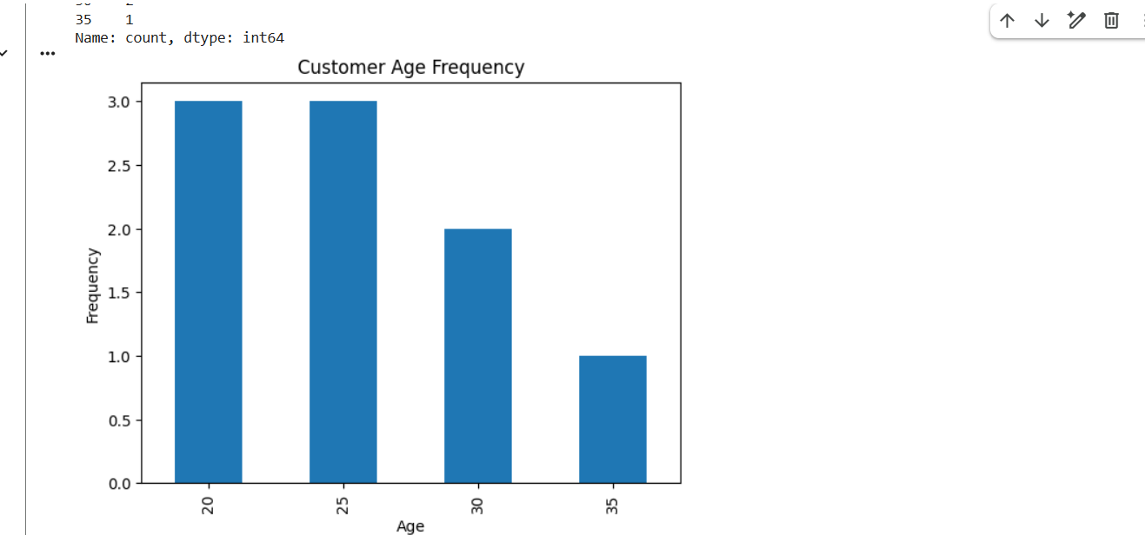

Question 15: Frequency Distribution of Likes
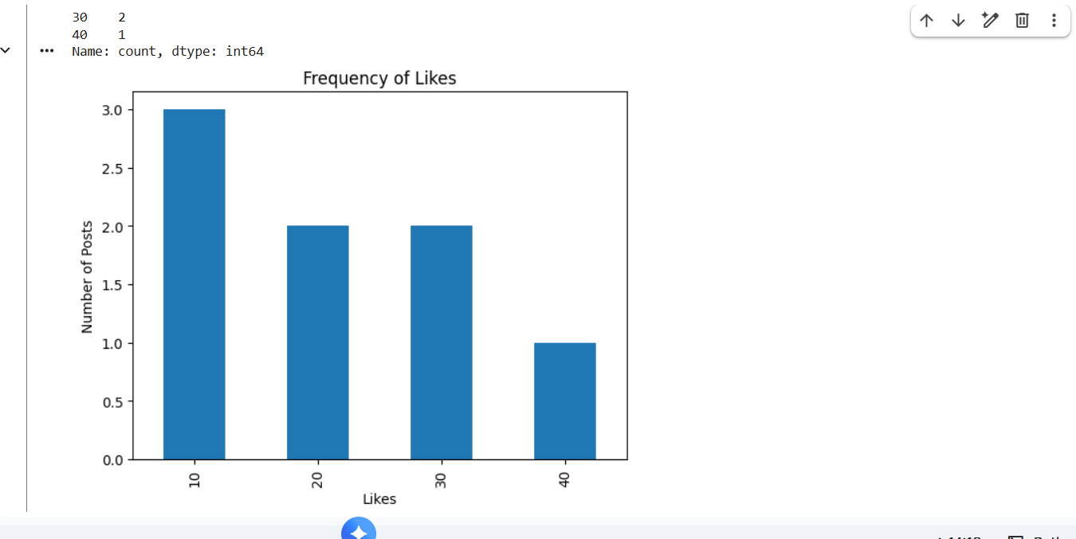

Question 16: Word Frequency in Customer Reviews
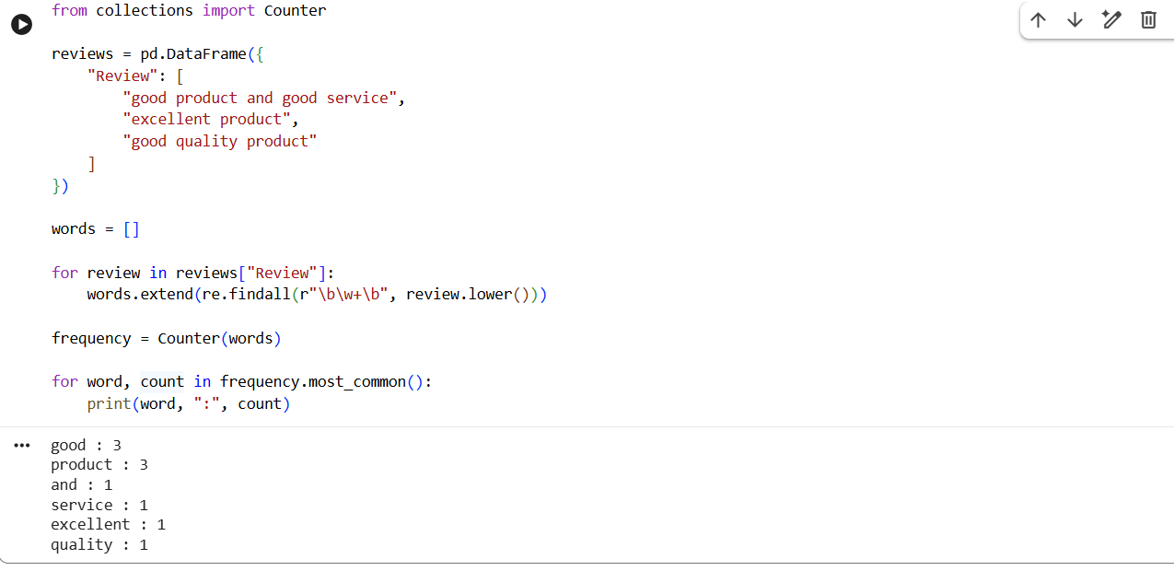

Question 17: Customer Feedback – Top N Word Frequency
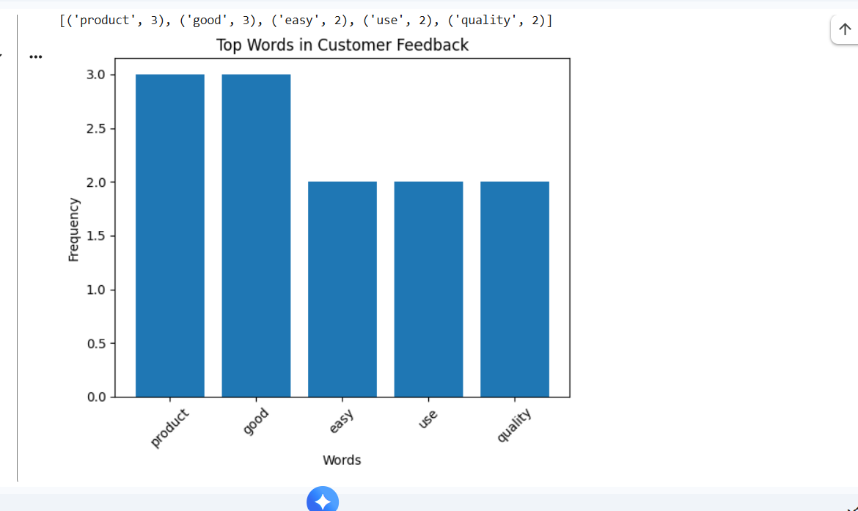

Question 18: Mean, Median, Standard Deviation, Boxplot, Scatter Plot and Q-Q Plot
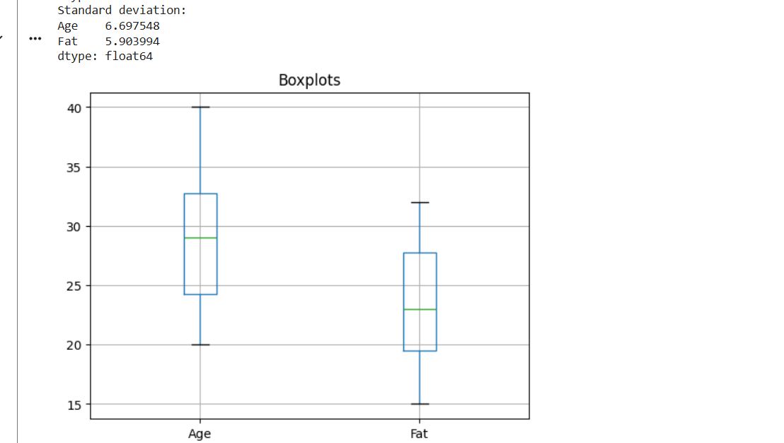
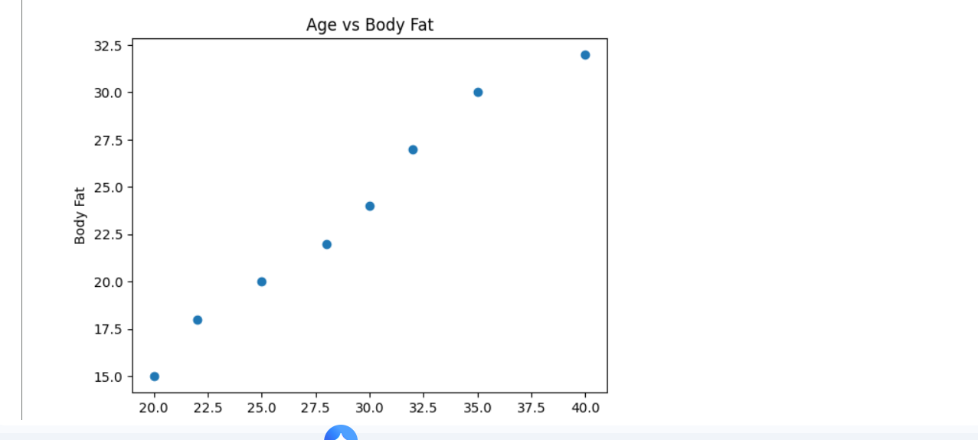

Question 19: 95% Confidence Interval for Blood Pressure Reduction
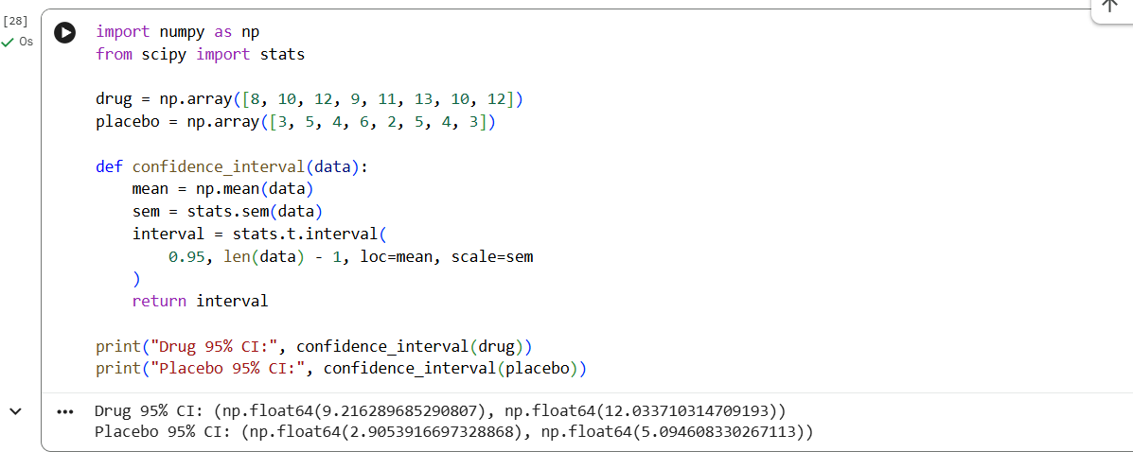

Question 20: A/B Test – Compare Two Conversion Rate Samples
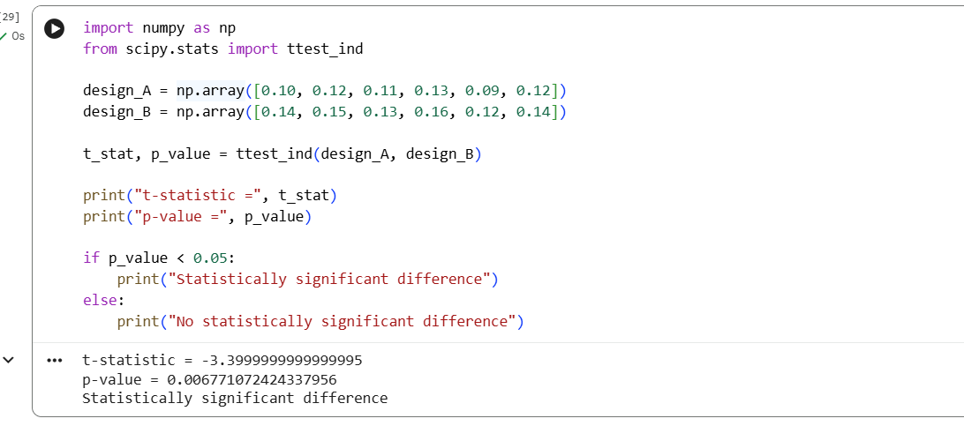

Question 21: Point Estimate and Confidence Interval from CSV
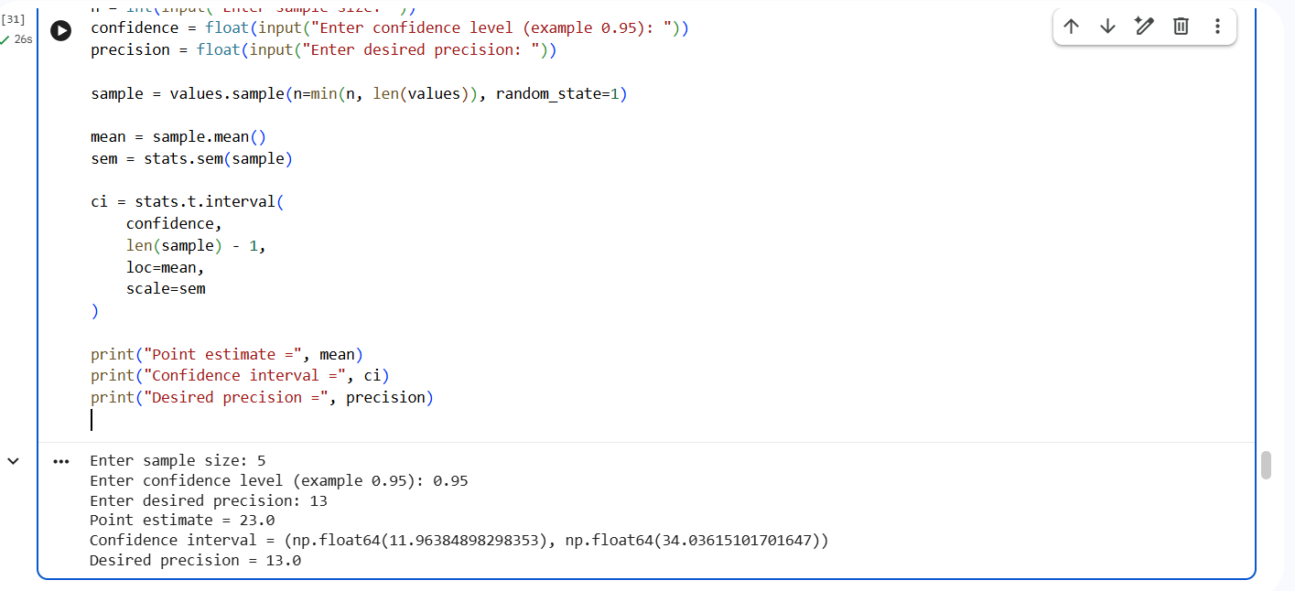

Question 22: Confidence Interval for Mean Customer Rating
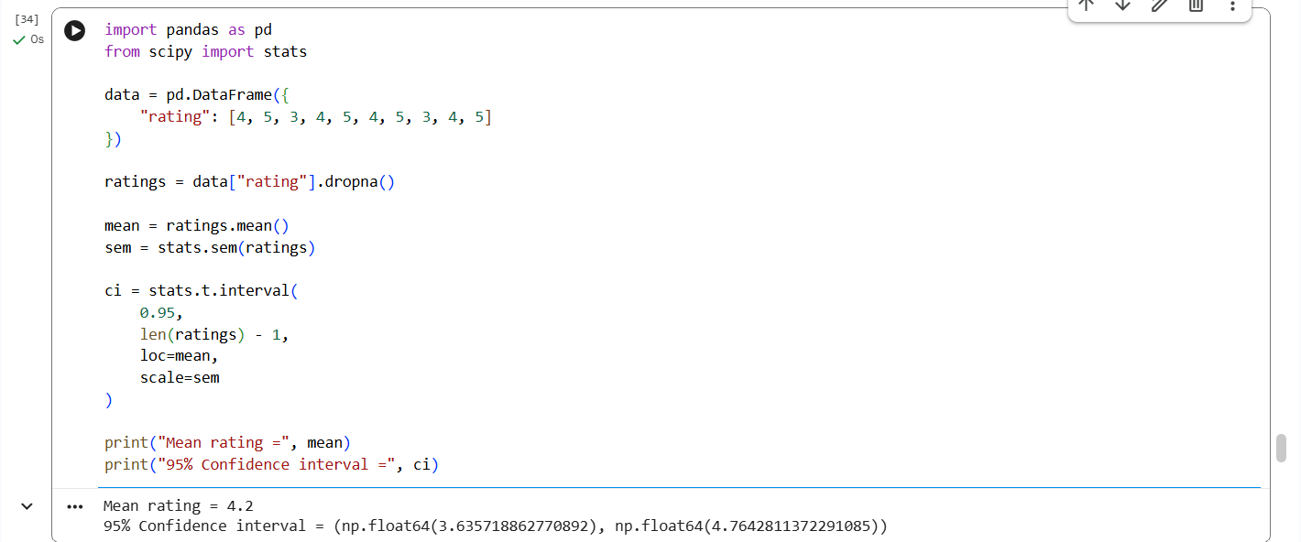

Question 23: Hypothesis Testing for Treatment vs Placebo
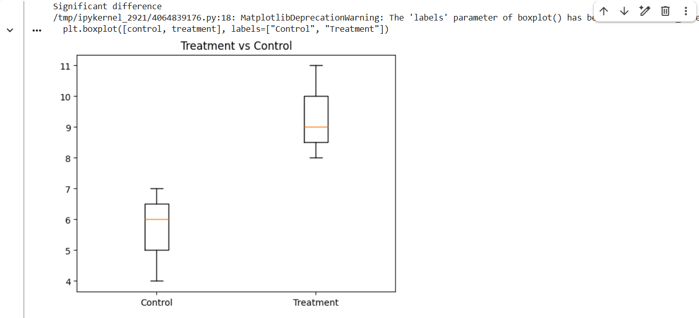

Question 24: KNN Classifier for a New Patient
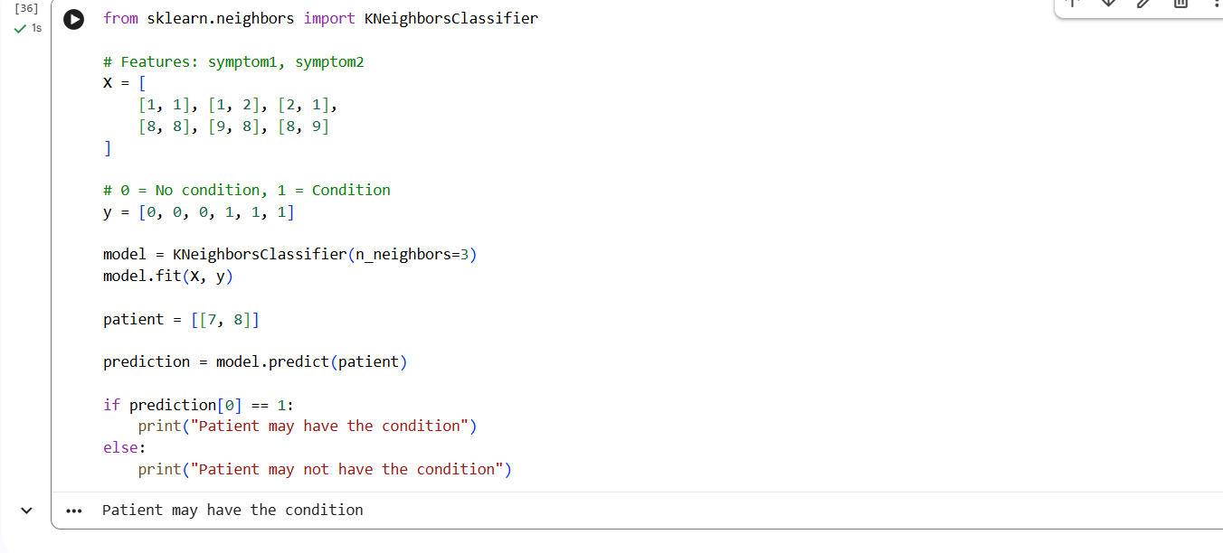

Question 25: Decision Tree for Iris Classification
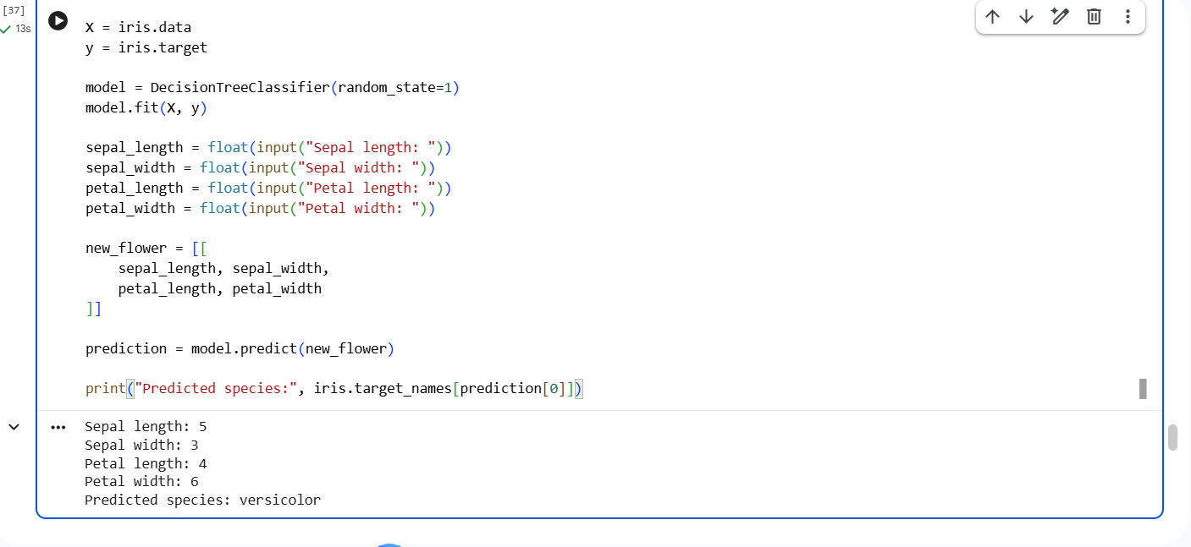

Question 26: Linear Regression for Housing Price Prediction
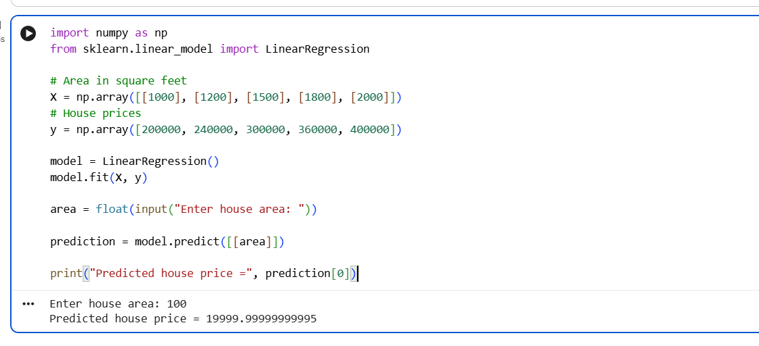

Question 27: Logistic Regression for Customer Churn
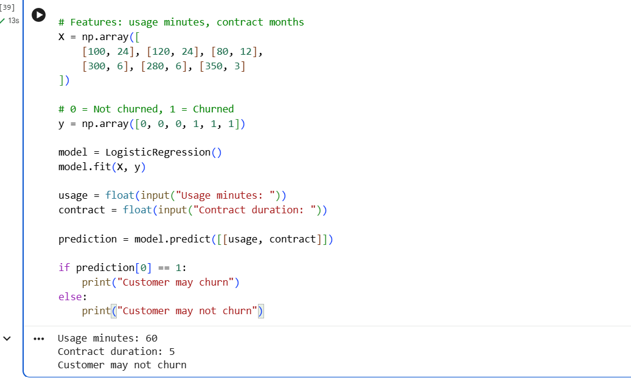

Question 28: K-Means Customer Segmentation
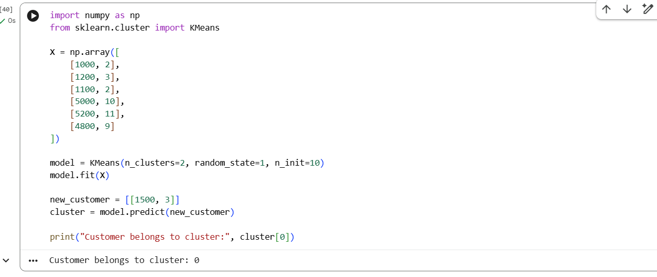

Question 29: Accuracy, Precision, Recall and F1-Score
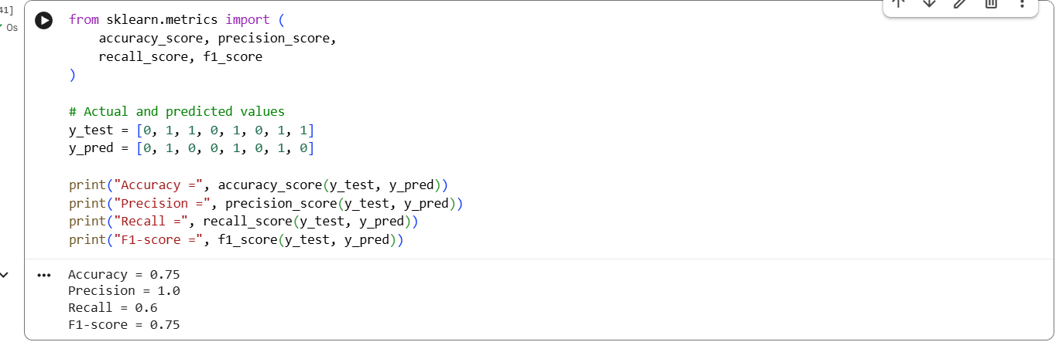

Question 30: CART Regression for Used Car Price
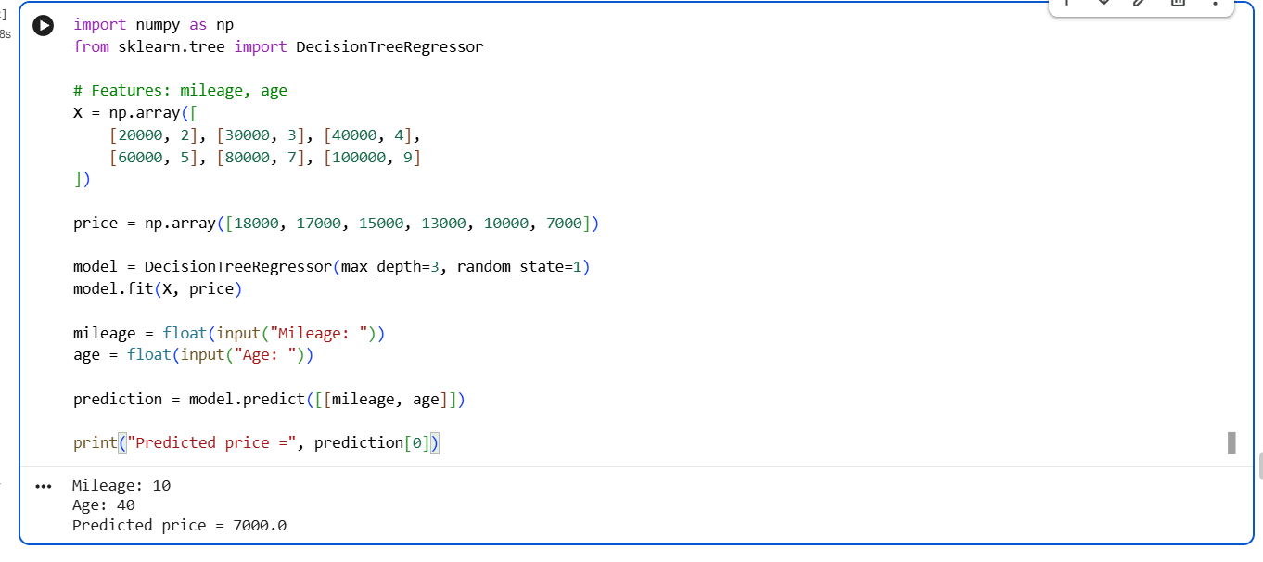

Question 31: Customer Segmentation using K-Means
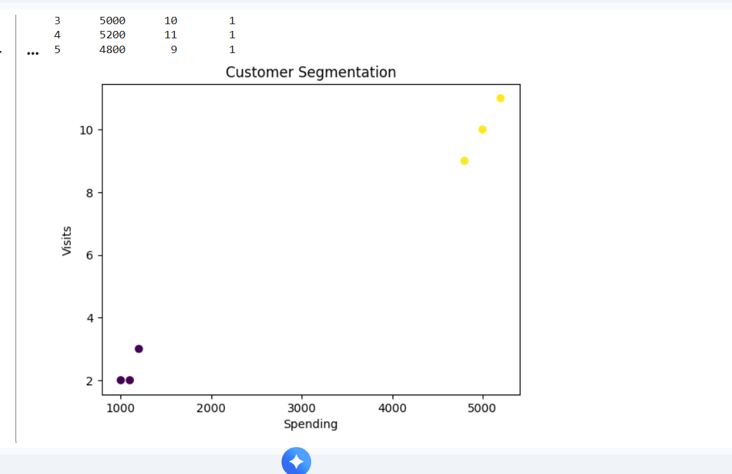

Question 32: Bivariate Analysis and Linear Regression for House Price
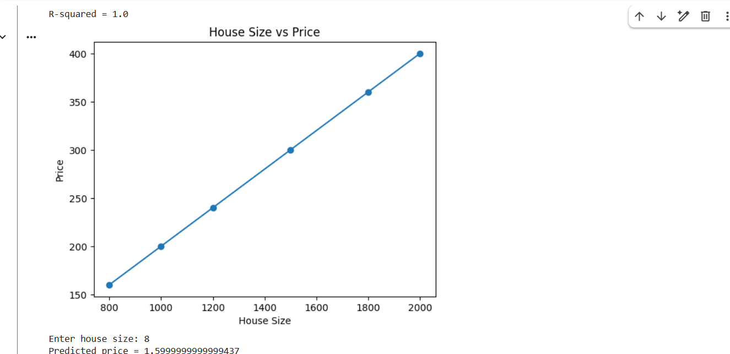

Question 33: Multiple Linear Regression for Car Price
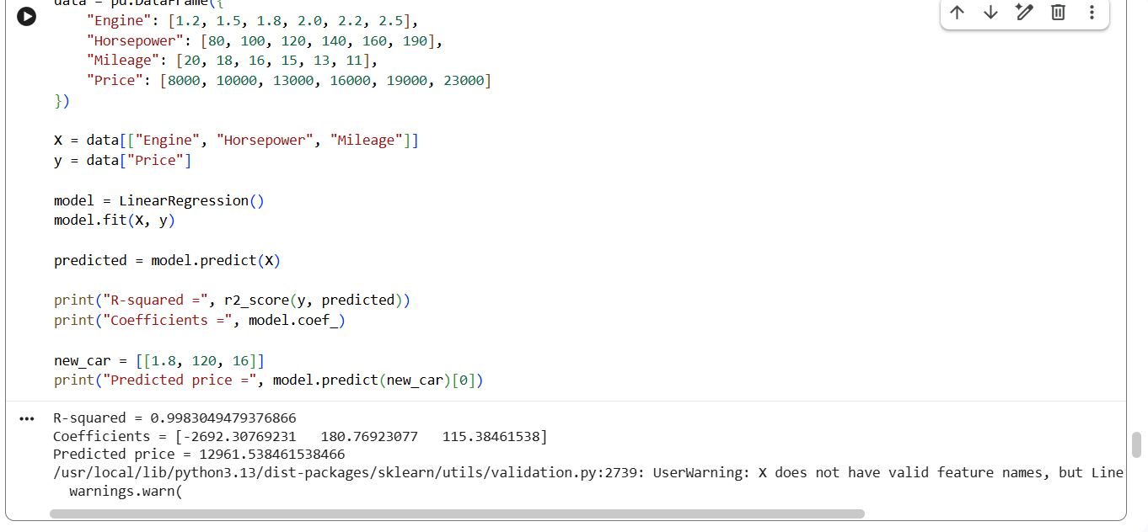

Question 34: KNN Classification with Evaluation Metrics
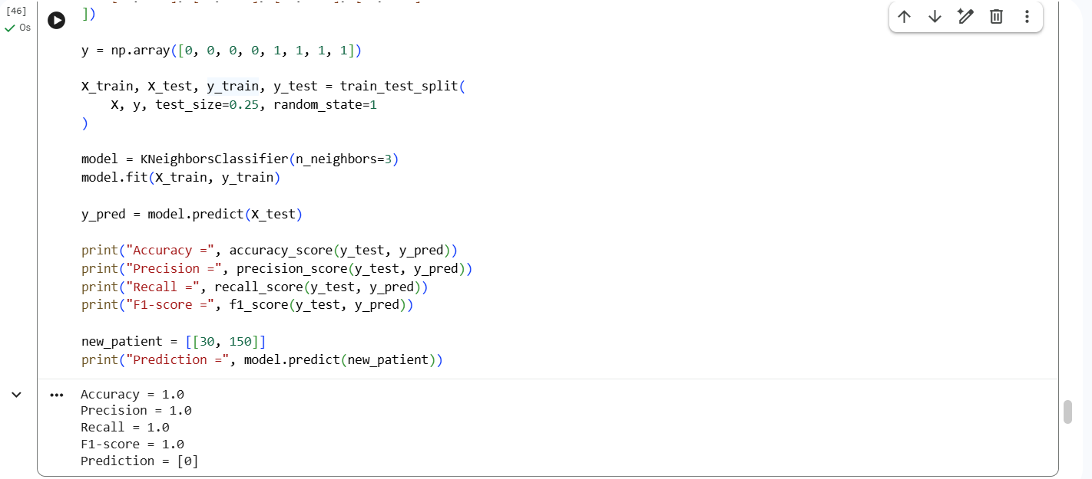

Question 35: K-Means Clustering for Retail Customers
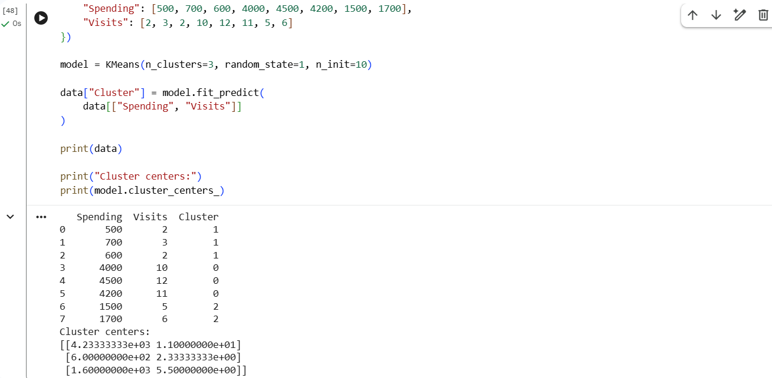

Question 36: Stock Price Variability from CSV
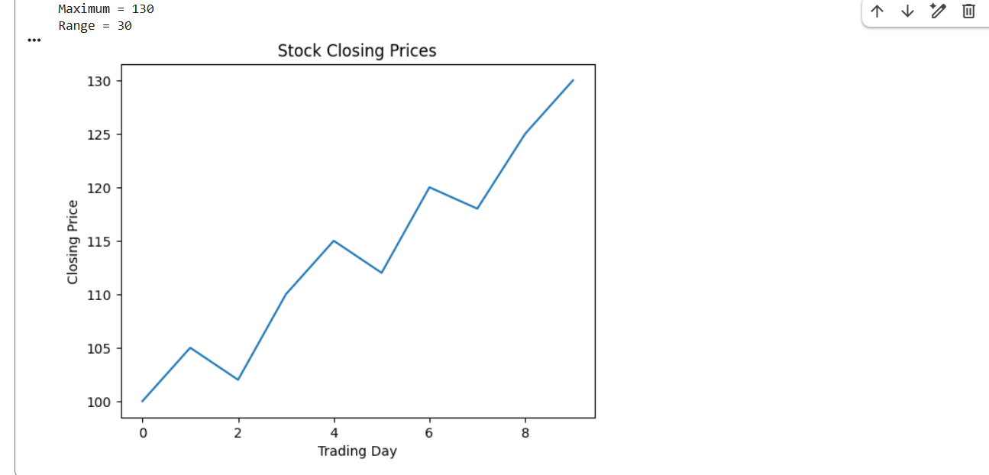

Question 37: Correlation between Study Time and Exam Score
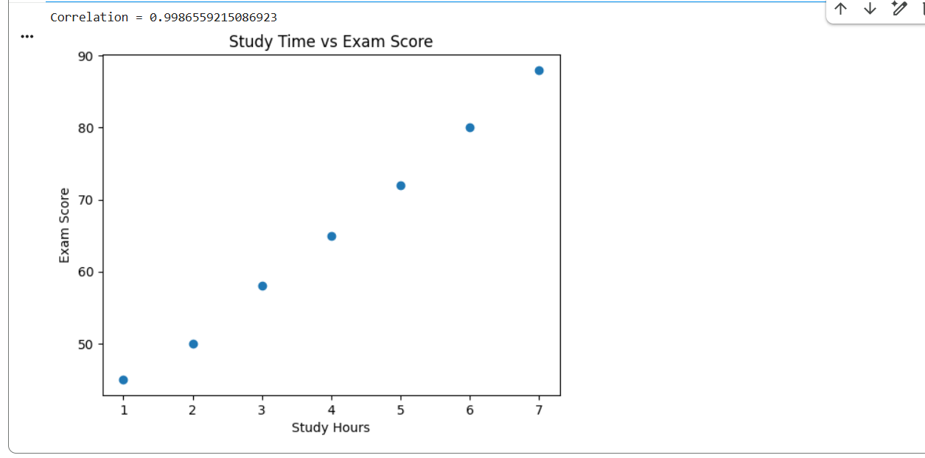

Question 38: Temperature Analysis for Different Cities
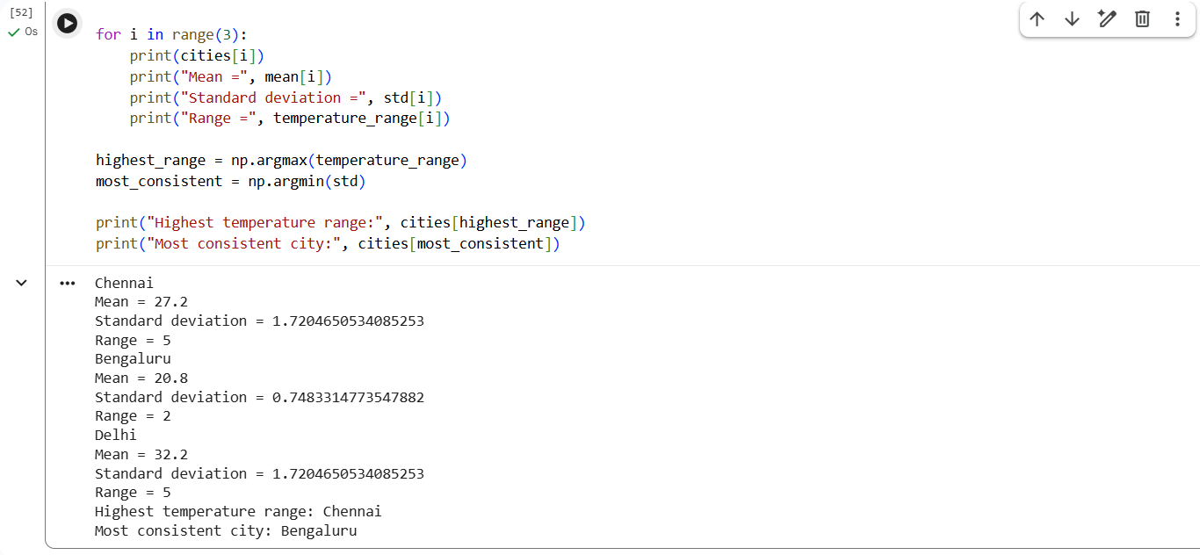

Question 39: K-Means Clustering and Visualization
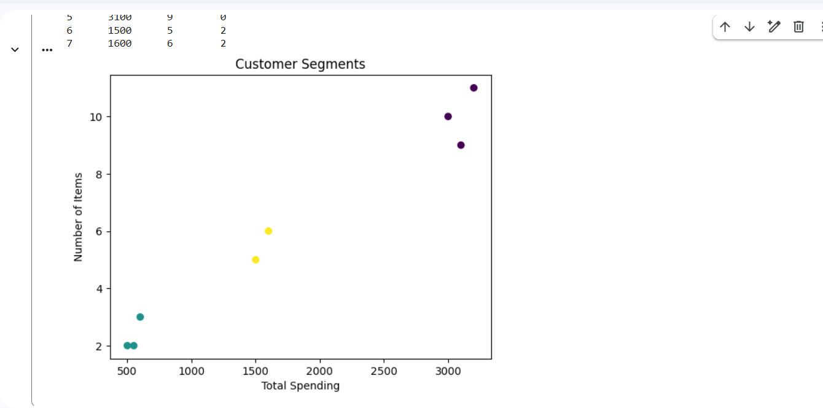

Question 40: Soccer Player Analysis using Pandas
